Vytváranie tabuliek / Create table :

CREATE TABLE Dodavatel

(

ID_Dodavatela VARCHAR NOT NULL,

Dod_Tel_c BIGINT NOT NULL,

ICO INT(8) NOT NULL,

Adresa VARCHAR NOT NULL,

Nazov VARCHAR NOT NULL,

PRIMARY KEY (ID_Dodavatela)

);

CREATE TABLE Dodavaci_list

(

ID_dod_list INT NOT NULL AUTO_INCREMENT,

ID_Dodavatela INT NOT NULL,

Cena FLOAT NOT NULL,

Datum DATE NOT NULL,

Mnozstvo INT NOT NULL,

Merna_jednotka VARCHAR(15) NOT NULL,

PRIMARY KEY (ID_dod_list),

FOREIGN KEY (ID_Dodavatela) REFERENCES Dodavatel(ID_Dodavatela)

);

CREATE TABLE Material

(

ID_materialu INT NOT NULL,

Cena FLOAT NOT NULL,

Nazov VARCHAR(30) NOT NULL,

Mnozstvo INT NOT NULL,

Merna_jednotka VARCHAR (15) NOT NULL,

PRIMARY KEY (ID_materialu)

);

CREATE TABLE Recept

(

ID_Recept INT NOT NULL,

Nazov VARCHAR(40) NOT NULL,

PRIMARY KEY (ID_Recept)

);

CREATE TABLE Ingredencie

(

ID_Ingredencie INT NOT NULL,

Mnozstvo INT NOT NULL,

Cena_materialov FLOAT NOT NULL,

Ingredencia1 VARCHAR(30) NOT NULL,

Ingredencia2 VARCHAR(30) NOT NULL,

Ingredencia3 VARCHAR(30) NOT NULL,

Ingredencia4 VARCHAR(30) NOT NULL,

PRIMARY KEY (ID_Ingredencie)

);

CREATE TABLE Vyrobok

(

ID_Vyrobku INT NOT NULL,

Mnozstvo INT NOT NULL,

Predajna_cena FLOAT NOT NULL,

Nazov VARCHAR(40) NOT NULL,

Marza FLOAT NOT NULL,

PRIMARY KEY (ID_Vyrobku)

);

CREATE TABLE Objednavka

(

ID_objednavky INT NOT NULL,

Cas INT NOT NULL,

Mnozstvo INT NOT NULL,

Cena FLOAT NOT NULL,

Celk_Cena FLOAT NOT NULL,

PRIMARY KEY (ID_objednavky)

);

CREATE TABLE Zakaznik

(

ID_zakaznika INT NOT NULL,

Zak_adresa VARCHAR(200) NOT NULL,

Zak_tel_c BIGINT NOT NULL,

PRIMARY KEY (ID_zakaznika)

);

CREATE TABLE Historia_Objednavok_Transakcii

(

ID_Hist INT NOT NULL,

PRIMARY KEY (ID_Hist)

);

CREATE TABLE Transakcia

(

ID_transakcie INT NOT NULL,

Cena Float not null,

Cas INT Not null,

Typ_transakcie VARCHAR(20) NOT NULL,

PRIMARY Key (ID_transakcie)

);

CREATE TABLE Pokladnica

(

ID_Pokladnice INT NOT NULL,

Mnozstvo FLOAT NOT NULL,

PRIMARY KEY (ID_Pokladnice)

);

CREATE TABLE Bankovy_ucet

(

ID_Bank_uct INT NOT NULL,

Cislo_bank_uctu VARCHAR(24) NOT NULL,

Mnozstvo Float NOT NULL,

Nazov VARCHAR (50) NOT NULL,

PRIMARY KEY (ID_Bank_uct)

);

CREATE TABLE Energie

(

ID_Energie INT NOT NULL,

Typ VARCHAR (15) NOT NULL,

Cena Float not null,

Mesiac VARCHAR (15) NOT NULL,

Vyuz_mnozstvo FLOAT NOT NULL,

PRIMARY Key (ID_Energie)

);

CREATE TABLE Dodavatel_Energie

(

ID_Dod_energie INT NOT NULL,

Typ VARCHAR (15) NOT NULL,

Cena FLOAT NOT NULL,

Mnozstvo INT NOT NULL,

Merna_jednotka VARCHAR(15) NOT NULL,

Dod_Ene_Tel_c BIGINT NOT NULL,

PRIMARY KEY (ID_Dod_energie)

);

CREATE TABLE Spotreba_Stroj

(

ID_Spotreba_Stroj INT NOT NULL,

Vyuz_mnozstvo FLOAT NOT NULL,

Typ_stroja VARCHAR (50) NOT NULL,

Merna_jednotka VARCHAR (15) NOT NULL,

Typ_energie VARCHAR (15) NOT NULL,

Nazov VARCHAR (50) NOT NULL,

PRIMARY Key (ID_Spotreba_Stroj)

);

CREATE TABLE Stroj

(

ID_Stroja INT NOT NULL,

Nazov VARCHAR(50) NOT NULL,

PRIMARY KEY (ID_Stroja)

);

CREATE TABLE Opotrebenie_stroja

(

ID_Opotrebenie_stroja INT NOT NULL,

Aktualny_datum VARCHAR (30) NOT NULL,

Datum_zaradenia VARCHAR (30) NOT NULL,

PRIMARY KEY (ID_Opotrebenie_stroja)

);

CREATE TABLE Oddelenie

(

ID_oddelenia INT NOT NULL,

Nazov VARCHAR(50) NOT NULL,

PRIMARY Key (ID_oddelenia)

);

CREATE TABLE Zamestnanec

(

ID_Zamestnanca INT NOT NULL,

Meno VARCHAR (20) NOT NULL,

Priezvisko VARCHAR (30) Not null,

Pohlavie varchar (10) Not null,

Vyplata FLOAT NOT NULL,

Zam_tel_c BIGINT NOT NULL,

Rola_zamestnanca VARCHAR (30) NOT NULL,

PRIMARY KEY (ID_Zamestnanca)

);

CREATE TABLE Vyuzite_stroje

(

ID_Vyuzite_stroje INT NOT NULL,

stroj1 VARCHAR (50) Not null,

stroj2 VARCHAR (50) Not null,

stroj3 VARCHAR (50) Not null,

stroj4 VARCHAR (50) Not null,

stroj5 VARCHAR (50) Not null,

Merna_jednotka VARCHAR (15) Not null,

Vyuz_Mnozstvo FLOAT Not null,

Primary Key (ID_Vyuzite_stroje)

);

Pridanie FK :

ALTER TABLE Dodavaci_list

ADD ID_materialu INT NOT NULL,

ADD FOREIGN KEY (ID_materialu) REFERENCES Material(ID_materialu);

ALTER TABLE Dodavatel_Energie

ADD ID_Energie INT NOT NULL,

ADD FOREIGN KEY (ID_Energie) REFERENCES Energie(ID_Energie);

ALTER TABLE Energie

ADD ID_Dod_energie INT NOT NULL,

ADD FOREIGN KEY (ID_Dod_energie) REFERENCES Dodavatel_Energie(ID_Dod_energie);

ALTER TABLE Historia_Objednavok_Transakcii

ADD ID_objednavky INT NOT NULL,

ADD ID_transakcie INT NOT NULL,

ADD FOREIGN KEY (ID_objednavky) REFERENCES Objednavka(ID_objednavky),

ADD FOREIGN KEY (ID_transakcie) REFERENCES Transakcia(ID_transakcie);

ALTER TABLE Ingredencie

ADD ID_materialu INT NOT NULL,

ADD FOREIGN KEY (ID_materialu) REFERENCES Material(ID_materialu);

ALTER TABLE Material

ADD ID_dod_list INT NOT NULL,

ADD ID_Dodavatela INT NOT NULL,

ADD FOREIGN KEY (ID_dod_list) REFERENCES Dodavaci_list(ID_dod_list),

ADD FOREIGN KEY (ID_Dodavatela) REFERENCES Dodavatel(ID_Dodavatela);

ALTER TABLE Objednavka

ADD ID_Vyrobku INT NOT NULL,

ADD FOREIGN KEY (ID_Vyrobku) REFERENCES Vyrobok(ID_Vyrobku);

ALTER TABLE Oddelenie

ADD ID_Zamestnanca INT NOT NULL,

ADD FOREIGN KEY (ID_Zamestnanca) REFERENCES Zamestnanec(ID_Zamestnanca);

ALTER TABLE Recept

ADD ID_Vyrobku INT NOT NULL,

ADD ID_Ingredencie INT NOT NULL,

ADD ID_Vyuzite_stroje INT NOT NULL,

ADD FOREIGN KEY (ID_Vyrobku) REFERENCES Vyrobok(ID_Vyrobku),

ADD FOREIGN KEY (ID_Ingredencie) REFERENCES Ingredencie(ID_Ingredencie),

ADD FOREIGN KEY (ID_Vyuzite_stroje) REFERENCES Vyuzite_stroje(ID_Vyuzite_stroje);

ALTER TABLE Spotreba_Stroj

ADD ID_stroja INT NOT NULL,

ADD ID_Energie INT NOT NULL,

ADD FOREIGN KEY (ID_stroja) REFERENCES Stroj(ID_stroja),

ADD FOREIGN KEY (ID_Energie) REFERENCES Energie(ID_Energie);

Alter table Opotrebenie_stroja

add ID_Stroja INT NOT NULL,

ADD FOREIGN KEY (ID_Stroja) REFERENCES Stroj(ID_Stroja);

**INSERT INTO :   
VALUES :**

INSERT INTO Dodavatel

VALUES

(1, 421249496394, 31321828, "Cesta na Senec 2, 821 04 Bratislava Ruzinov", "TESCO STORES SR, a.s."),

(2, 421905324864, 46558802, "Lipova 473/99951 93 Topolcianky", "Top torticka"),

(3, 421917316838, 45613150, "Zafortna 555/25957 01 Banovce nad Bebravou Slovensko", "Zeleny obchodik"),

(4, 421908706050, 36472549, "LUNYS, s.r.o. Hlavna 4512/96 059 51 Poprad", "LUNYS, s.r.o."),

(5, 421948691481, 52069630, "Racianska 1509/31831 02 Bratislava Slovensko", "Cacaofe s.r.o.");

INSERT INTO Bankovy_ucet

VALUES

(1, "SK36 9477 5313 6131 7528 6266", 6466.04, "Hlavny ucet"),

(2, "SK39 7472 4105 3261 7904 6295", 2969.02, "Rezervny ucet"),

(3, "SK63 9994 7968 9378 2318 2835", 296.55, "Vedlajsi ucet"),

(4, "SK48 8896 5228 2226 3273 5216", 8561.11, "Energie ucet");

INSERT INTO Pokladnica

VALUES

(1, 5500.5),

(2, 637.8),

(3, 462.2);

INSERT INTO Zamestnanec

VALUES

(1,"Jozef","Novak","M", 2000.13 ,421903505070, "Sef"),

(2,"Helena","Vankova","F",1500.01,421903705815, "Uctovnicka"),

(3,"Maria","Rockova","F",980.71,421708025158, "Kucharka"),

(4,"Andrej","Gogo","M",350.60,421780954125, "Kasa"),

(5,"Eduard","Sucik","M",780.40,421529645287, "Skladnik");

INSERT INTO Oddelenie

VALUES

(1,"Sef",1),

(2,"Uctovnictvo Firmy",2),

(3,"Kuchyna",3),

(4,"Kasa",4),

(5,"Sklad",5);

INSERT INTO Stroj  
VALUES  
( 1, ,"Pocitac1 ", 1, 1 , 1),

( 2, ," Pocitac2",2 , 2, 2),

( 3, "Kasa ",4 ,4 ,3),

( 4, "Sporak ", 3 ,3 ,4 ),

( 5,"Chladnicka ",5 , 5, 5),

( 6," Zrmzlinovac",3 ,3 ,6 );

INSERT INTO Zakaznik

VALUES

(1,"Kostova 11 Bratislava", 09035859248),

(101, "Babilova 25 Marislava", 0905485297),

(55, "Mataninova 77 Ohnivova", 0904785921),

(74, "Hurikova 87 Malacky", 09035852671),

(500, "Malikova 8 Pezinok", 09045555555);

INSERT INTO Material

VALUES

(1,"Smotana_na_slahanie" ,"ml" ,1.50 ,200 ,3 ),

(2,"Mlieko" ,"ml" , 2.70,400 , 3),

(3,"Cukor" ,"g" ,2.40 ,1000 ,3 ),

(4,"Broskyňa" , "ks", 0.39, 1, 1),

(5, "Maliny","g" , 4.19, 125, 4),

(6,"Vanilkovy_extrakt" ,"cajova_lyzica" ,6.90 ,50, 2),

(7, "Arasidy", "g", 6.90 ,1000 , 1),

(8, "Arasidove_maslo" , "g", 3.99 , 6.90,1 ),

(9, "Oreo_susienka","ks" ,1.39 ,10 ,1 ),

(10,"Cokolada" ,"g" ,10.90 ,1000 ,2 ),

(11, "Kakao","poliev_lyzica" ,6.90 , 100,5 );

INSERT INTO Vyuzite_stroje

VALUES

(1, 6, 6, 1, "vyrobny proces", 500),

(2, 6, 3, 1, "vyrobny proces", 200);

INSERT INTO Spotreba_Stroj

VALUES

(1, 100, "hodina", "user-2222", "elektrina","Pocitac", 1, 3),

(2, 50, "hodina", "Chladnickator", "elektrina","Chladnicka", 1, 3),

(3, 200, "1 vyrobny proces", "Zmzrz", "elektrina","Zmrzlinovac", 1, 3),

(4, 20, "hodina", "LG kasa", "elektrina","Kasa", 1, 3),

(5, 100, "hodina", "Sporo", "plyn","Sporak", 1, 3),

(6, 500, "1 vyrobny proces", "Zmzrz", "voda","Zmrzlinovac", 1, 3),

(7, 100, "hodina", "user-2445", "elektrina","Pocitac", 2, 3);

INSERT INTO Energie

VALUES

(1, "plyn", 3000, "Januar", 2000, 1),

(2, "voda", 20000, "Januar", 4000, 2),

(3, "elektrina", 33000, "Januar", 10000, 3);

INSERT INTO Dodavatel_Energie

VALUES

(1, "plyn", 1.50, 1, "meterkubik", 42190405100),

(2, "voda", 5.00, 1,"meterkubik", 42190405060),

(3,"elektrina", 3.30, 1, "Kw", 42190770782);

INSERT INTO Ingredencia1

VALUES

(1, 1, 500, 'ml'),

(2, 1, 250, 'ml'),

(3, 1, 500, 'ml'),

(4, 1, 500, 'ml'),

(5, 1, 500, 'ml');

INSERT INTO Ingredencia2

VALUES

(1, 2, 300, 'ml'),

(2, 2, 250, 'ml'),

(3, 2, 300, 'ml'),

(4, 2, 300, 'ml'),

(5, 2, 250, 'ml');

INSERT INTO Ingredencia3

VALUES

(1,5,300,"g"),

(2,3,100,"g"),

(3,7,70,"g"),

(4,10,100,"g"),

(5,6,1,"cajova_lyzicka");

INSERT INTO Ingredencia4

VALUES

(1, 6, 5, 'cajova_lyzicka'),

(2, 4, 5, 'ks'),

(3, 8, 250, "g"),

(4, 11, 3, "g"),

(5, 9, 10, 'ks');

INSERT INTO Historia_Objednavok_Transakcii

VALUES

(1,1,1),

(2,2,2),

(3,3,3),

(4,4,4),

(5,5,5);

INSERT INTO Transakcia

VALUES

(1, 20.00,1000,"karta"),

(2, 35.00,2000,"karta"),

(3, 48.00,0800,"karta"),

(4, 21.00,0400,"hotovost"),

(5, 5.00,1200,"hotovost");

INSERT INTO Objednavka

VALUES

(1, 1000, 2, 10.00, 20.00,1),

(2, 2000, 5, 7.00, 35.00, 3),

(3, 0800, 6, 8.00, 48.00, 2),

(4, 0400, 1, 7.00, 21.00, 3),

(5, 1200, 1, 5.00, 5.00, 5);

Insert into Vyrobok

VALUES

(1, "Malinova", 10.00, 2.50),

(2, "Broskynova", 8.00, 5.00),

(3, "Arasidova", 7.00, 1.00),

(4, "Cokoladova", 11.00, 2.00),

(5, "Vanilkova", 5.00, 0.20);

INSERT INTO Recept

VALUES

(1,"Malinova",1,1,1,1,1),

(2,"Broskynova",2,2,2,2,2),

(3,"Arasidova",3,3,3,3,3),

(4,"Cokoladova",4,4,4,4,4),

(5,"Vanilkova",5,5,5,5,5);

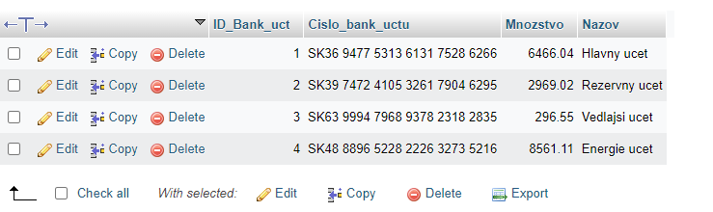

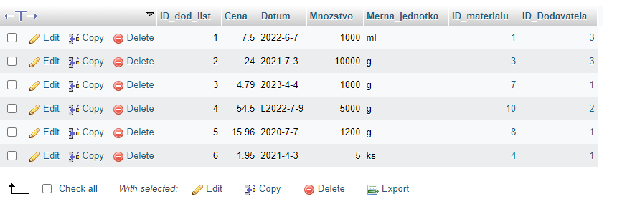

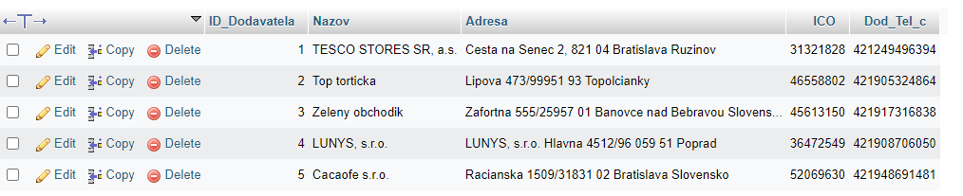

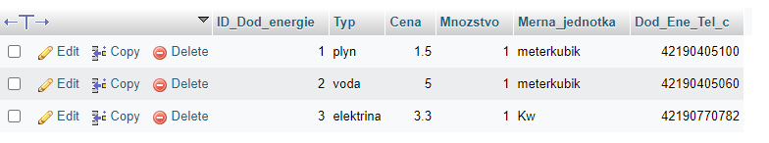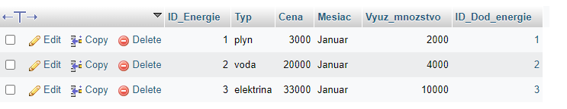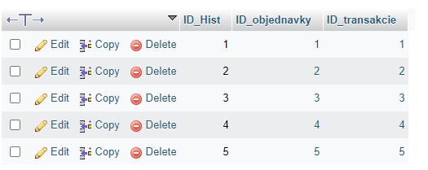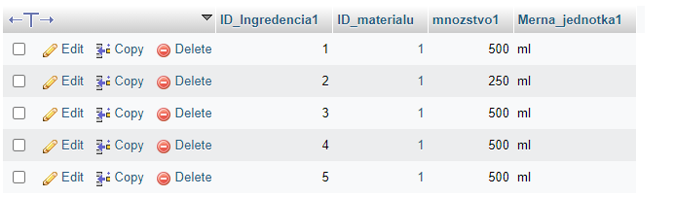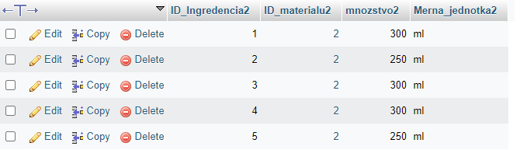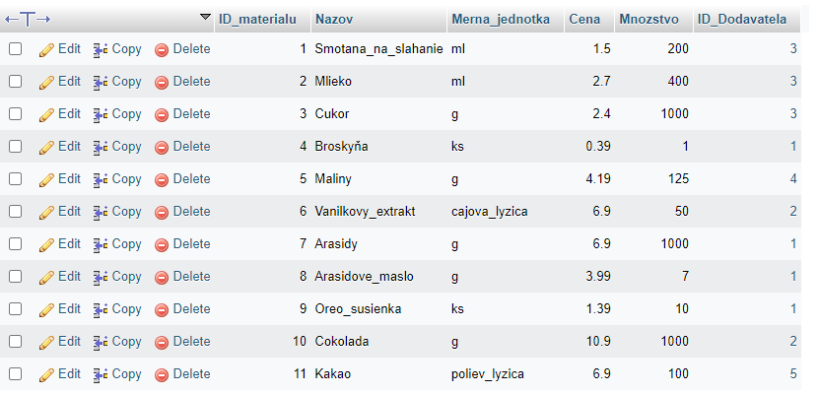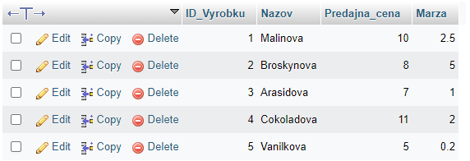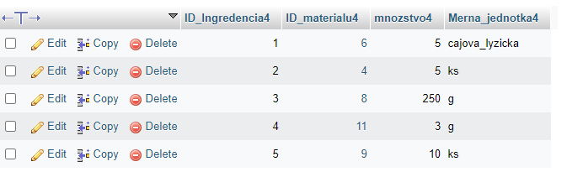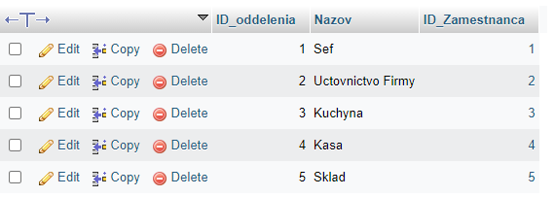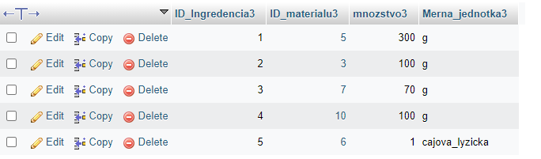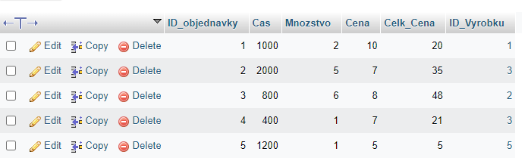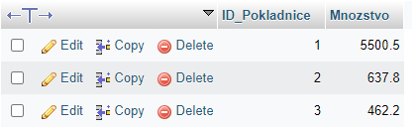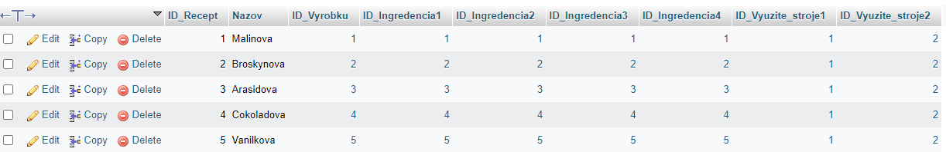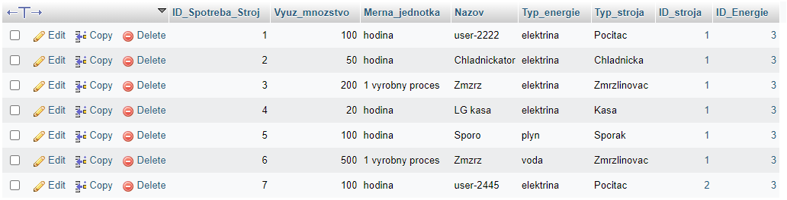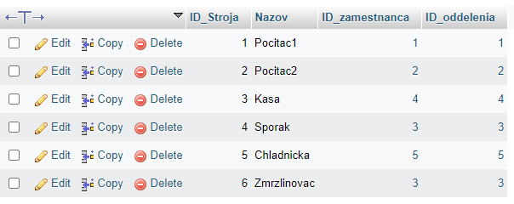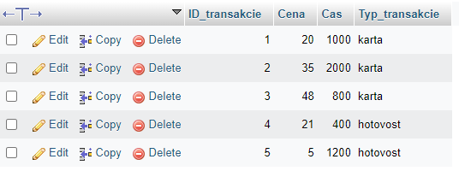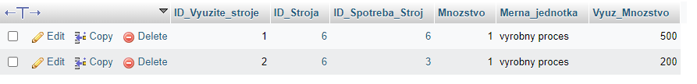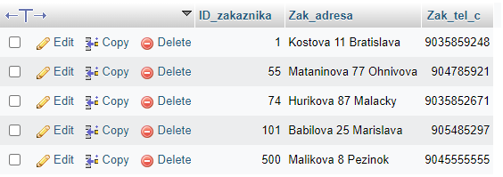

Keby náhodou som zabudol niečo tak tu je export :

INSERT INTO `Bankovy_ucet` (`ID_Bank_uct`, `Cislo_bank_uctu`, `Mnozstvo`, `Nazov`) VALUES

(1, 'SK36 9477 5313 6131 7528 6266', 6466.04, 'Hlavny ucet'),

(2, 'SK39 7472 4105 3261 7904 6295', 2969.02, 'Rezervny ucet'),

(3, 'SK63 9994 7968 9378 2318 2835', 296.55, 'Vedlajsi ucet'),

(4, 'SK48 8896 5228 2226 3273 5216', 8561.11, 'Energie ucet');

-- --------------------------------------------------------

CREATE TABLE `Dodavaci_list` (

`ID_dod_list` int NOT NULL,

`Cena` float NOT NULL,

`Datum` varchar(30) COLLATE utf8mb3_unicode_ci NOT NULL,

`Mnozstvo` int NOT NULL,

`Merna_jednotka` varchar(15) CHARACTER SET utf8mb3 COLLATE utf8mb3_unicode_ci NOT NULL,

`ID_materialu` int NOT NULL,

`ID_Dodavatela` int NOT NULL

) ENGINE=InnoDB DEFAULT CHARSET=utf8mb3 COLLATE=utf8mb3_unicode_ci;

INSERT INTO `Dodavaci_list`

VALUES

(1, 7.5, '2022-6-7', 1000, 'ml', 1, 3),

(2, 24, '2021-7-3', 10000, 'g', 3, 3),

(3, 4.79, '2023-4-4', 1000, 'g', 7, 1),

(4, 54.5, 'L2022-7-9', 5000, 'g', 10, 2),

(5, 15.96, '2020-7-7', 1200, 'g', 8, 1),

(6, 1.95, '2021-4-3', 5, 'ks', 4, 1);

-- --------------------------------------------------------

CREATE TABLE `Dodavatel` (

`ID_Dodavatela` int NOT NULL,

`Nazov` varchar(100) CHARACTER SET utf8mb3 COLLATE utf8mb3_unicode_ci NOT NULL,

`Adresa` varchar(100) CHARACTER SET utf8mb3 COLLATE utf8mb3_unicode_ci NOT NULL,

`ICO` int NOT NULL,

`Dod_Tel_c` bigint NOT NULL

) ENGINE=InnoDB DEFAULT CHARSET=utf8mb3 COLLATE=utf8mb3_unicode_ci;

INSERT INTO `Dodavatel` (`ID_Dodavatela`, `Nazov`, `Adresa`, `ICO`, `Dod_Tel_c`) VALUES

(1, 'TESCO STORES SR, a.s.', 'Cesta na Senec 2, 821 04 Bratislava Ruzinov', 31321828, 421249496394),

(2, 'Top torticka', 'Lipova 473/99951 93 Topolcianky', 46558802, 421905324864),

(3, 'Zeleny obchodik', 'Zafortna 555/25957 01 Banovce nad Bebravou Slovensko', 45613150, 421917316838),

(4, 'LUNYS, s.r.o.', 'LUNYS, s.r.o. Hlavna 4512/96 059 51 Poprad', 36472549, 421908706050),

(5, 'Cacaofe s.r.o.', 'Racianska 1509/31831 02 Bratislava Slovensko', 52069630, 421948691481);

-- --------------------------------------------------------

CREATE TABLE `Dodavatel_Energie` (

`ID_Dod_energie` int NOT NULL,

`Typ` varchar(15) COLLATE utf8mb3_unicode_ci NOT NULL,

`Cena` float NOT NULL,

`Mnozstvo` int NOT NULL,

`Merna_jednotka` varchar(15) CHARACTER SET utf8mb3 COLLATE utf8mb3_unicode_ci NOT NULL,

`Dod_Ene_Tel_c` bigint NOT NULL

) ENGINE=InnoDB DEFAULT CHARSET=utf8mb3 COLLATE=utf8mb3_unicode_ci;

INSERT INTO `Dodavatel_Energie`

VALUES

(1, 'plyn', 1.5, 1, 'meterkubik', 42190405100),

(2, 'voda', 5, 1, 'meterkubik', 42190405060),

(3, 'elektrina', 3.3, 1, 'Kw', 42190770782);

-- --------------------------------------------------------

CREATE TABLE `Energie`

`ID_Energie` int NOT NULL,

`Typ` varchar(15) COLLATE utf8mb3_unicode_ci NOT NULL,

`Cena` float NOT NULL,

`Mesiac` varchar(15) COLLATE utf8mb3_unicode_ci NOT NULL,

`Vyuz_mnozstvo` float NOT NULL,

`ID_Dod_energie` int NOT NULL

) ENGINE=InnoDB DEFAULT CHARSET=utf8mb3 COLLATE=utf8mb3_unicode_ci;

INSERT INTO `Energie` (`ID_Energie`, `Typ`, `Cena`, `Mesiac`, `Vyuz_mnozstvo`, `ID_Dod_energie`) VALUES

(1, 'plyn', 3000, 'Januar', 2000, 1),

(2, 'voda', 20000, 'Januar', 4000, 2),

(3, 'elektrina', 33000, 'Januar', 10000, 3);

-- --------------------------------------------------------

CREATE TABLE `Historia_Objednavok_Transakcii` (

`ID_Hist` int NOT NULL,

`ID_objednavky` int NOT NULL,

`ID_transakcie` int NOT NULL

) ENGINE=InnoDB DEFAULT CHARSET=utf8mb3 COLLATE=utf8mb3_unicode_ci;

INSERT INTO `Historia_Objednavok_Transakcii`

VALUES

(1, 1, 1),

(2, 2, 2),

(3, 3, 3),

(4, 4, 4),

(5, 5, 5);

-- --------------------------------------------------------

CREATE TABLE `Ingredencia1` (

`ID_Ingredencia1` int NOT NULL,

`ID_materialu` int NOT NULL,

`mnozstvo1` int NOT NULL,

`Merna_jednotka1` varchar(15) COLLATE utf8mb3_unicode_ci NOT NULL

) ENGINE=InnoDB DEFAULT CHARSET=utf8mb3 COLLATE=utf8mb3_unicode_ci;

INSERT INTO `Ingredencia1` (`ID_Ingredencia1`, `ID_materialu`, `mnozstvo1`, `Merna_jednotka1`) VALUES

(1, 1, 500, 'ml'),

(2, 1, 250, 'ml'),

(3, 1, 500, 'ml'),

(4, 1, 500, 'ml'),

(5, 1, 500, 'ml');

-- --------------------------------------------------------

CREATE TABLE `Ingredencia2` (

`ID_Ingredencia2` int NOT NULL,

`ID_materialu2` int NOT NULL,

`mnozstvo2` int NOT NULL,

`Merna_jednotka2` varchar(15) COLLATE utf8mb3_unicode_ci NOT NULL

) ENGINE=InnoDB DEFAULT CHARSET=utf8mb3 COLLATE=utf8mb3_unicode_ci;

INSERT INTO `Ingredencia2` (`ID_Ingredencia2`, `ID_materialu2`, `mnozstvo2`, `Merna_jednotka2`) VALUES

(1, 2, 300, 'ml'),

(2, 2, 250, 'ml'),

(3, 2, 300, 'ml'),

(4, 2, 300, 'ml'),

(5, 2, 250, 'ml');

-- --------------------------------------------------------

CREATE TABLE `Ingredencia3` (

`ID_Ingredencia3` int NOT NULL,

`ID_materialu3` int NOT NULL,

`mnozstvo3` int NOT NULL,

`Merna_jednotka3` varchar(15) COLLATE utf8mb3_unicode_ci NOT NULL

) ENGINE=InnoDB DEFAULT CHARSET=utf8mb3 COLLATE=utf8mb3_unicode_ci;

INSERT INTO `Ingredencia3` (`ID_Ingredencia3`, `ID_materialu3`, `mnozstvo3`, `Merna_jednotka3`) VALUES

(1, 5, 300, 'g'),

(2, 3, 100, 'g'),

(3, 7, 70, 'g'),

(4, 10, 100, 'g'),

(5, 6, 1, 'cajova_lyzicka');

-- --------------------------------------------------------

CREATE TABLE `Ingredencia4` (

`ID_Ingredencia4` int NOT NULL,

`ID_materialu4` int NOT NULL,

`mnozstvo4` int NOT NULL,

`Merna_jednotka4` varchar(15) COLLATE utf8mb3_unicode_ci NOT NULL

) ENGINE=InnoDB DEFAULT CHARSET=utf8mb3 COLLATE=utf8mb3_unicode_ci;

INSERT INTO `Ingredencia4` (`ID_Ingredencia4`, `ID_materialu4`, `mnozstvo4`, `Merna_jednotka4`) VALUES

(1, 6, 5, 'cajova_lyzicka'),

(2, 4, 5, 'ks'),

(3, 8, 250, 'g'),

(4, 11, 3, 'g'),

(5, 9, 10, 'ks');

-- --------------------------------------------------------

CREATE TABLE `Material` (

`ID_materialu` int NOT NULL,

`Nazov` varchar(30) CHARACTER SET utf8mb3 COLLATE utf8mb3_unicode_ci NOT NULL,

`Merna_jednotka` varchar(15) CHARACTER SET utf8mb3 COLLATE utf8mb3_unicode_ci NOT NULL,

`Cena` float NOT NULL,

`Mnozstvo` int NOT NULL,

`ID_Dodavatela` int NOT NULL

) ENGINE=InnoDB DEFAULT CHARSET=utf8mb3 COLLATE=utf8mb3_unicode_ci;

INSERT INTO `Material` (`ID_materialu`, `Nazov`, `Merna_jednotka`, `Cena`, `Mnozstvo`, `ID_Dodavatela`) VALUES

(1, 'Smotana_na_slahanie', 'ml', 1.5, 200, 3),

(2, 'Mlieko', 'ml', 2.7, 400, 3),

(3, 'Cukor', 'g', 2.4, 1000, 3),

(4, 'Broskyňa', 'ks', 0.39, 1, 1),

(5, 'Maliny', 'g', 4.19, 125, 4),

(6, 'Vanilkovy_extrakt', 'cajova_lyzica', 6.9, 50, 2),

(7, 'Arasidy', 'g', 6.9, 1000, 1),

(8, 'Arasidove_maslo', 'g', 3.99, 7, 1),

(9, 'Oreo_susienka', 'ks', 1.39, 10, 1),

(10, 'Cokolada', 'g', 10.9, 1000, 2),

(11, 'Kakao', 'poliev_lyzica', 6.9, 100, 5);

-- --------------------------------------------------------

CREATE TABLE `Objednavka` (

`ID_objednavky` int NOT NULL,

`Cas` int NOT NULL,

`Mnozstvo` int NOT NULL,

`Cena` float NOT NULL,

`Celk_Cena` float NOT NULL,

`ID_Vyrobku` int NOT NULL

) ENGINE=InnoDB DEFAULT CHARSET=utf8mb3 COLLATE=utf8mb3_unicode_ci;

INSERT INTO `Objednavka` (`ID_objednavky`, `Cas`, `Mnozstvo`, `Cena`, `Celk_Cena`, `ID_Vyrobku`) VALUES

(1, 1000, 2, 10, 20, 1),

(2, 2000, 5, 7, 35, 3),

(3, 800, 6, 8, 48, 2),

(4, 400, 1, 7, 21, 3),

(5, 1200, 1, 5, 5, 5);

-- --------------------------------------------------------

CREATE TABLE `Oddelenie` (

`ID_oddelenia` int NOT NULL,

`Nazov` varchar(50) COLLATE utf8mb3_unicode_ci NOT NULL,

`ID_Zamestnanca` int NOT NULL

) ENGINE=InnoDB DEFAULT CHARSET=utf8mb3 COLLATE=utf8mb3_unicode_ci;

INSERT INTO `Oddelenie` (`ID_oddelenia`, `Nazov`, `ID_Zamestnanca`) VALUES

(1, 'Sef', 1),

(2, 'Uctovnictvo Firmy', 2),

(3, 'Kuchyna', 3),

(4, 'Kasa', 4),

(5, 'Sklad', 5);

-- --------------------------------------------------------

CREATE TABLE `Pokladnica` (

`ID_Pokladnice` int NOT NULL,

`Mnozstvo` float NOT NULL

) ENGINE=InnoDB DEFAULT CHARSET=utf8mb3 COLLATE=utf8mb3_unicode_ci;

INSERT INTO `Pokladnica` (`ID_Pokladnice`, `Mnozstvo`) VALUES

(1, 5500.5),

(2, 637.8),

(3, 462.2);

-- --------------------------------------------------------

CREATE TABLE `Recept` (

`ID_Recept` int NOT NULL,

`Nazov` varchar(40) COLLATE utf8mb3_unicode_ci NOT NULL,

`ID_Vyrobku` int NOT NULL,

`ID_Ingredencia1` int NOT NULL,

`ID_Ingredencia2` int NOT NULL,

`ID_Ingredencia3` int NOT NULL,

`ID_Ingredencia4` int NOT NULL,

`ID_Vyuzite_stroje1` int NOT NULL,

`ID_Vyuzite_stroje2` int NOT NULL

) ENGINE=InnoDB DEFAULT CHARSET=utf8mb3 COLLATE=utf8mb3_unicode_ci;

INSERT INTO `Recept` (`ID_Recept`, `Nazov`, `ID_Vyrobku`, `ID_Ingredencia1`, `ID_Ingredencia2`, `ID_Ingredencia3`, `ID_Ingredencia4`, `ID_Vyuzite_stroje1`, `ID_Vyuzite_stroje2`) VALUES

(1, 'Malinova', 1, 1, 1, 1, 1, 1, 2),

(2, 'Broskynova', 2, 2, 2, 2, 2, 1, 2),

(3, 'Arasidova', 3, 3, 3, 3, 3, 1, 2),

(4, 'Cokoladova', 4, 4, 4, 4, 4, 1, 2),

(5, 'Vanilkova', 5, 5, 5, 5, 5, 1, 2);

-- --------------------------------------------------------

CREATE TABLE `Spotreba_Stroj` (

`ID_Spotreba_Stroj` int NOT NULL,

`Vyuz_mnozstvo` float NOT NULL,

`Merna_jednotka` varchar(30) CHARACTER SET utf8mb3 COLLATE utf8mb3_unicode_ci NOT NULL,

`Nazov` varchar(50) CHARACTER SET utf8mb3 COLLATE utf8mb3_unicode_ci NOT NULL,

`Typ_energie` varchar(15) CHARACTER SET utf8mb3 COLLATE utf8mb3_unicode_ci NOT NULL,

`Typ_stroja` varchar(50) COLLATE utf8mb3_unicode_ci NOT NULL,

`ID_stroja` int NOT NULL,

`ID_Energie` int NOT NULL

) ENGINE=InnoDB DEFAULT CHARSET=utf8mb3 COLLATE=utf8mb3_unicode_ci;

INSERT INTO `Spotreba_Stroj` (`ID_Spotreba_Stroj`, `Vyuz_mnozstvo`, `Merna_jednotka`, `Nazov`, `Typ_energie`, `Typ_stroja`, `ID_stroja`, `ID_Energie`) VALUES

(1, 100, 'hodina', 'user-2222', 'elektrina', 'Pocitac', 1, 3),

(2, 50, 'hodina', 'Chladnickator', 'elektrina', 'Chladnicka', 1, 3),

(3, 200, '1 vyrobny proces', 'Zmzrz', 'elektrina', 'Zmrzlinovac', 1, 3),

(4, 20, 'hodina', 'LG kasa', 'elektrina', 'Kasa', 1, 3),

(5, 100, 'hodina', 'Sporo', 'plyn', 'Sporak', 1, 3),

(6, 500, '1 vyrobny proces', 'Zmzrz', 'voda', 'Zmrzlinovac', 1, 3),

(7, 100, 'hodina', 'user-2445', 'elektrina', 'Pocitac', 2, 3);

-- --------------------------------------------------------

CREATE TABLE `Stroj` (

`ID_Stroja` int NOT NULL,

`Nazov` varchar(50) COLLATE utf8mb3_unicode_ci NOT NULL,

`ID_zamestnanca` int NOT NULL,

`ID_oddelenia` int NOT NULL

) ENGINE=InnoDB DEFAULT CHARSET=utf8mb3 COLLATE=utf8mb3_unicode_ci;

INSERT INTO `Stroj` (`ID_Stroja`, `Nazov`, `ID_zamestnanca`, `ID_oddelenia`) VALUES

(1, 'Pocitac1', 1, 1),

(2, 'Pocitac2', 2, 2),

(3, 'Kasa', 4, 4),

(4, 'Sporak', 3, 3),

(5, 'Chladnicka', 5, 5),

(6, 'Zmrzlinovac', 3, 3);

-- --------------------------------------------------------

CREATE TABLE `Transakcia` (

`ID_transakcie` int NOT NULL,

`Cena` float NOT NULL,

`Cas` int NOT NULL,

`Typ_transakcie` varchar(20) COLLATE utf8mb3_unicode_ci NOT NULL

) ENGINE=InnoDB DEFAULT CHARSET=utf8mb3 COLLATE=utf8mb3_unicode_ci;

INSERT INTO `Transakcia` (`ID_transakcie`, `Cena`, `Cas`, `Typ_transakcie`) VALUES

(1, 20, 1000, 'karta'),

(2, 35, 2000, 'karta'),

(3, 48, 800, 'karta'),

(4, 21, 400, 'hotovost'),

(5, 5, 1200, 'hotovost');

-- --------------------------------------------------------

CREATE TABLE `Vyrobok` (

`ID_Vyrobku` int NOT NULL,

`Nazov` varchar(40) CHARACTER SET utf8mb3 COLLATE utf8mb3_unicode_ci NOT NULL,

`Predajna_cena` float NOT NULL,

`Marza` float NOT NULL

) ENGINE=InnoDB DEFAULT CHARSET=utf8mb3 COLLATE=utf8mb3_unicode_ci;

INSERT INTO `Vyrobok` (`ID_Vyrobku`, `Nazov`, `Predajna_cena`, `Marza`) VALUES

(1, 'Malinova', 10, 2.5),

(2, 'Broskynova', 8, 5),

(3, 'Arasidova', 7, 1),

(4, 'Cokoladova', 11, 2),

(5, 'Vanilkova', 5, 0.2);

-- --------------------------------------------------------

CREATE TABLE `Vyuzite_stroje` (

`ID_Vyuzite_stroje` int NOT NULL,

`ID_Stroja` int NOT NULL,

`ID_Spotreba_Stroj` int NOT NULL,

`Mnozstvo` int NOT NULL,

`Merna_jednotka` varchar(15) CHARACTER SET utf8mb3 COLLATE utf8mb3_unicode_ci NOT NULL,

`Vyuz_Mnozstvo` float NOT NULL

) ENGINE=InnoDB DEFAULT CHARSET=utf8mb3 COLLATE=utf8mb3_unicode_ci;

INSERT INTO `Vyuzite_stroje` (`ID_Vyuzite_stroje`, `ID_Stroja`, `ID_Spotreba_Stroj`, `Mnozstvo`, `Merna_jednotka`, `Vyuz_Mnozstvo`) VALUES

(1, 6, 6, 1, 'vyrobny proces', 500),

(2, 6, 3, 1, 'vyrobny proces', 200);

CREATE TABLE `Zakaznik` (

`ID_zakaznika` int NOT NULL,

`Zak_adresa` varchar(200) COLLATE utf8mb3_unicode_ci NOT NULL,

`Zak_tel_c` bigint NOT NULL

) ENGINE=InnoDB DEFAULT CHARSET=utf8mb3 COLLATE=utf8mb3_unicode_ci;

INSERT INTO `Zakaznik` (`ID_zakaznika`, `Zak_adresa`, `Zak_tel_c`) VALUES

(1, 'Kostova 11 Bratislava', 9035859248),

(55, 'Mataninova 77 Ohnivova', 904785921),

(74, 'Hurikova 87 Malacky', 9035852671),

(101, 'Babilova 25 Marislava', 905485297),

(500, 'Malikova 8 Pezinok', 9045555555);

CREATE TABLE `Zamestnanec` (

`ID_Zamestnanca` int NOT NULL,

`Meno` varchar(20) COLLATE utf8mb3_unicode_ci NOT NULL,

`Priezvisko` varchar(30) COLLATE utf8mb3_unicode_ci NOT NULL,

`Pohlavie` varchar(10) COLLATE utf8mb3_unicode_ci NOT NULL,

`Vyplata` float NOT NULL,

`Zam_tel_c` bigint NOT NULL,

`Rola_zamestnanca` varchar(30) COLLATE utf8mb3_unicode_ci NOT NULL

) ENGINE=InnoDB DEFAULT CHARSET=utf8mb3 COLLATE=utf8mb3_unicode_ci;

INSERT INTO `Zamestnanec` (`ID_Zamestnanca`, `Meno`, `Priezvisko`, `Pohlavie`, `Vyplata`, `Zam_tel_c`, `Rola_zamestnanca`) VALUES

(1, 'Jozef', 'Novak', 'M', 2000.13, 421903505070, 'Sef'),

(2, 'Helena', 'Vankova', 'F', 1500.01, 421903705815, 'Uctovnicka'),

(3, 'Maria', 'Rockova', 'F', 980.71, 421708025158, 'Kucharka'),

(4, 'Andrej', 'Gogo', 'M', 350.6, 421780954125, 'Kasa'),

(5, 'Eduard', 'Sucik', 'M', 780.4, 421529645287, 'Skladnik');